Advance Laboratory: The Millikan Oil-Drop Experiment
*Mesuga, Reymond R., Ramos, Lian Angelo B., and Tupas, Jason Carl Martin A.
Deaprtment of Physical Sciences, College of Science
Polytechnic University of the Philippines, Manila
*email: rrmesuga@iskolarngbayan.pup.edu.ph

Abstract
Physicist Robert Millikan experimentally explained the magnitude of an electron’s charge using a series of oil-drop experiments. This method consisted of introducing a charged oil droplet between two oppositely charged parallel plates, and manipulating the magnitude of the electric field as well as the electric force of the droplets. This paper aims to replicate the Millikan’s Oil-Drop experiment to determine the value of e from the data gathered in experiment. The resulting value of e = 1.61 x 10^19 C as expected before the experiment.

1. Introduction

In 1909, physicist Robert Millikan examined the existence of a fundamental charge using a variety of experiments. Millikan hypothesized that smallest unit of charge did exist in nature. He believed that there was an elementary charge (e), in which the magnitude of the electric charge carried by a proton was equal to the absolute value of the electric charge of an electron. Lastly, he hypothesized that the amount of the picked up by any droplet is a whole numbered multiple of the fundamental physical constant.

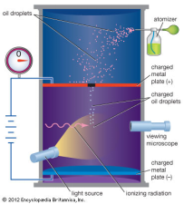
In his experiment, oil was sprayed in very fine drops (about 10^-4 mm in diameter) into the space between two parallel horizontal plates separeated by a distance d. A potential difference was maintained between the plates, causing a downward electric foeld between them. Some of the oil drops acquired a negative charge because of friction effects or because of ionization of the surrounding air by x rays or radioactivity. The drops were observed through a microscope and the device was called an electrical Microbalance.
During Millikan’s successful experiment, Oil droplets were sprayed in a fine mist from an atomizer, becoming charged due to friction, through a small hole in the upper plate of a set of parallel plates. The parallel plates were oppositely charged due to a connection to a variable power source (e.g., its potential difference could be varied). By adjusting the potential difference between the plates, Millikan was able to adjust the electric field to get individual droplets to balance between the plates. This was possible because the droplets had the same charge as the charge on the bottom plate. By adjusting the electrical repulsion force, Millikan was adjusting the electrical repulsive force of the bottom plate onto the electron so that it would be equal but opposite to the force of gravity. The mass of the droplet was calculated when the potential difference between the plates was removed, and the droplet fell at terminal velocity (a constant rate) with only the force of gravity and the force of friction acting on it. As more and more trials were done, it became evident that all of the droplets contained charges that were multiples of a smallest value. He correctly concluded that this must be the value on an electron, and therefore the value of the elementary charge, 1.602 × 10⁻¹⁹ C. For this work and later research on the photoelectric effect, Millikan received the Nobel Prize in 1923.

2. Results and Discussion

The Millikan oil-drop experiment was repeated four times and gathered the values listed

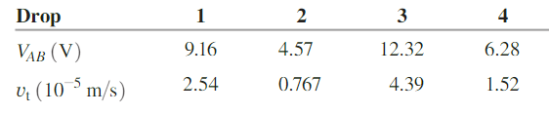

Table 1: Values of and in four trials.

In the apparatus, the separation d between the horizontal plates is 1.00 mm. The density of the oil used is 824 kg/m^3. For the viscosity η of air, the value used is 1.81 x 10^-5 N*s/m^2. Eq. (1) is used to calculate the charge of electron,

eq.(1)

where d = 1.00 x 10^-3 m, ρ = 824 kg/m^3, η = 1.81 x 10^-5 N*s/m^2 and g = 9.8. The resulting data is as folllows:

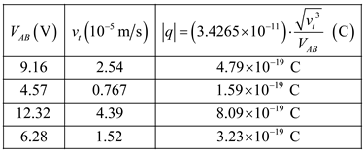

Table 1: Values of , and in four trials.

